**XYZ collage Holiday Problem**

**Spoofing Email Addresses**

## **Story Scenario: The Principal’s Fake Holiday Email**

In XYZ College, the festive season is approaching, and all the students are eagerly hoping for a day off to celebrate. They decide to request a holiday from the principal. A large group gathers and submits their request, but the principal, known for strict discipline, refuses to grant a holiday, insisting that classes continue as scheduled.



Among the students is Aryan, who is not only clever but also a skilled hacker. Aryan sees an opportunity to play a prank and demonstrate the risks of email spoofing. Later that night, Aryan sets up his system to send a fake email to all students—but this email will appear to come directly from the principal’s official address.



The next morning, every student receives an email that reads:

## **Introduction**

In this lab exercise, we will use [VirtualBox](https://www.virtualbox.org/wiki/Downloads) Manager as our virtualization tool. It is one of the many available virtualization platforms.

| Subject: Today is a Holiday

From: principal@xyzcollege.edu

Dear Students, As per the latest instructions, today will be a holiday for all students. No classes will be held.

Enjoy your time! Best Regards,

Principal XYZ College

### **Prerequisites**

Ensure the following before starting:

* Your computer (Windows or macOS) has at least **8 GB of RAM**.
* [VirtualBox](https://www.virtualbox.org/wiki/Downloads) is downloaded and installed.
* The OS for spoofing an email we are using is KALI. You can download the virtual box file, or you can go with the ISO file.
* For VDI you can skip the installation

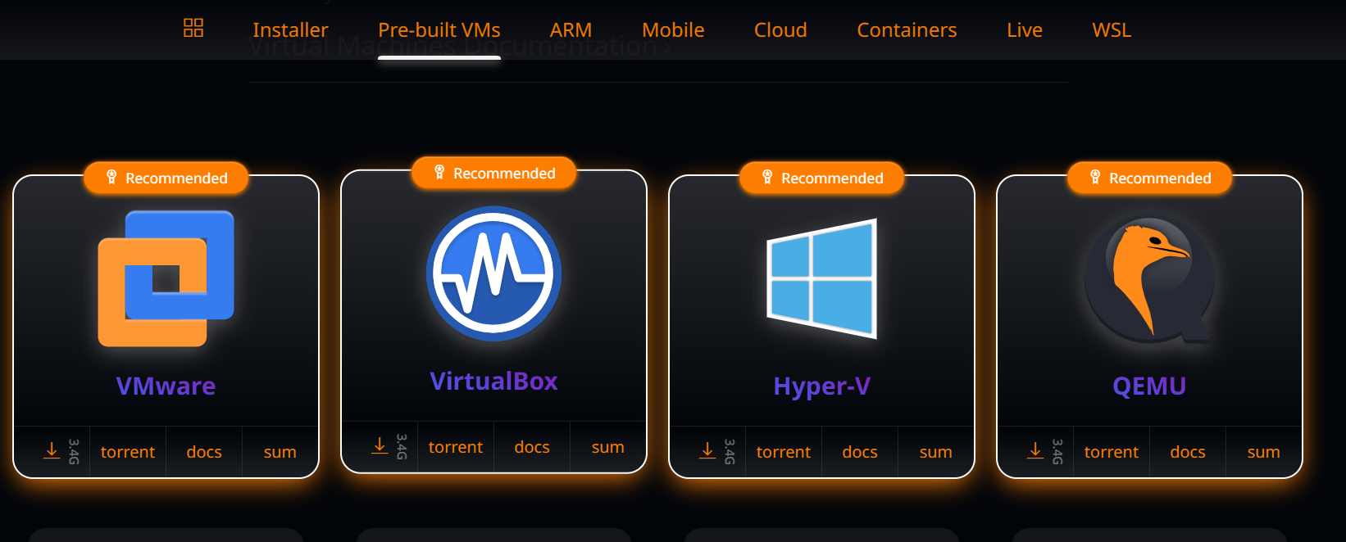

## **Step 1: Launch VirtualBox Manager**

* Click the downloaded file it will automatically configure in your virtual machine (VM).

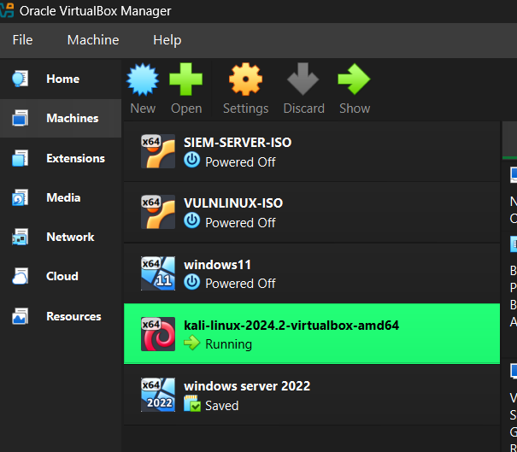

* Enter the password of the machine. Default user: kali password: kali



**Step 2: Update your kali**

* Then open the terminal from the top and type the command

| apt update

| apt upgrade

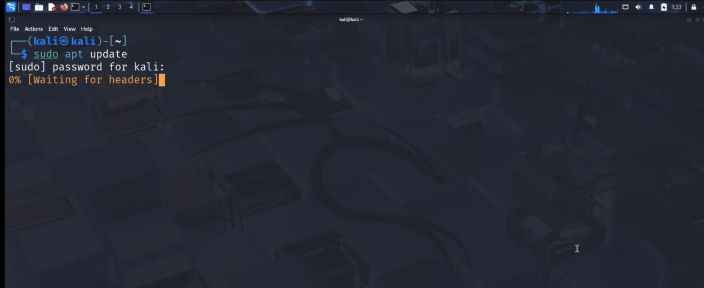

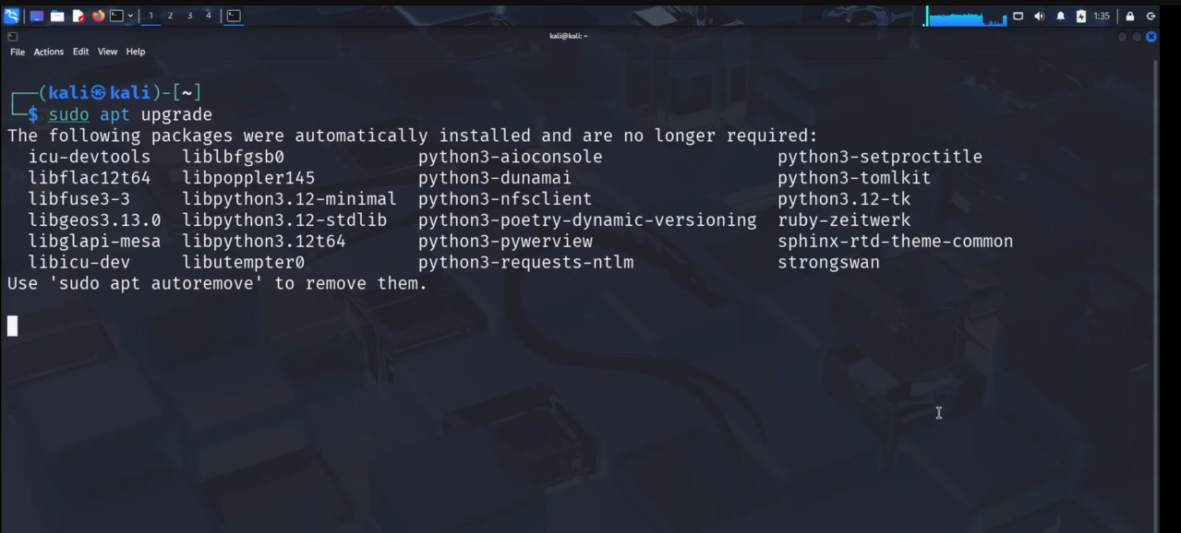

**Step 3: Install Email spoofing Tool**

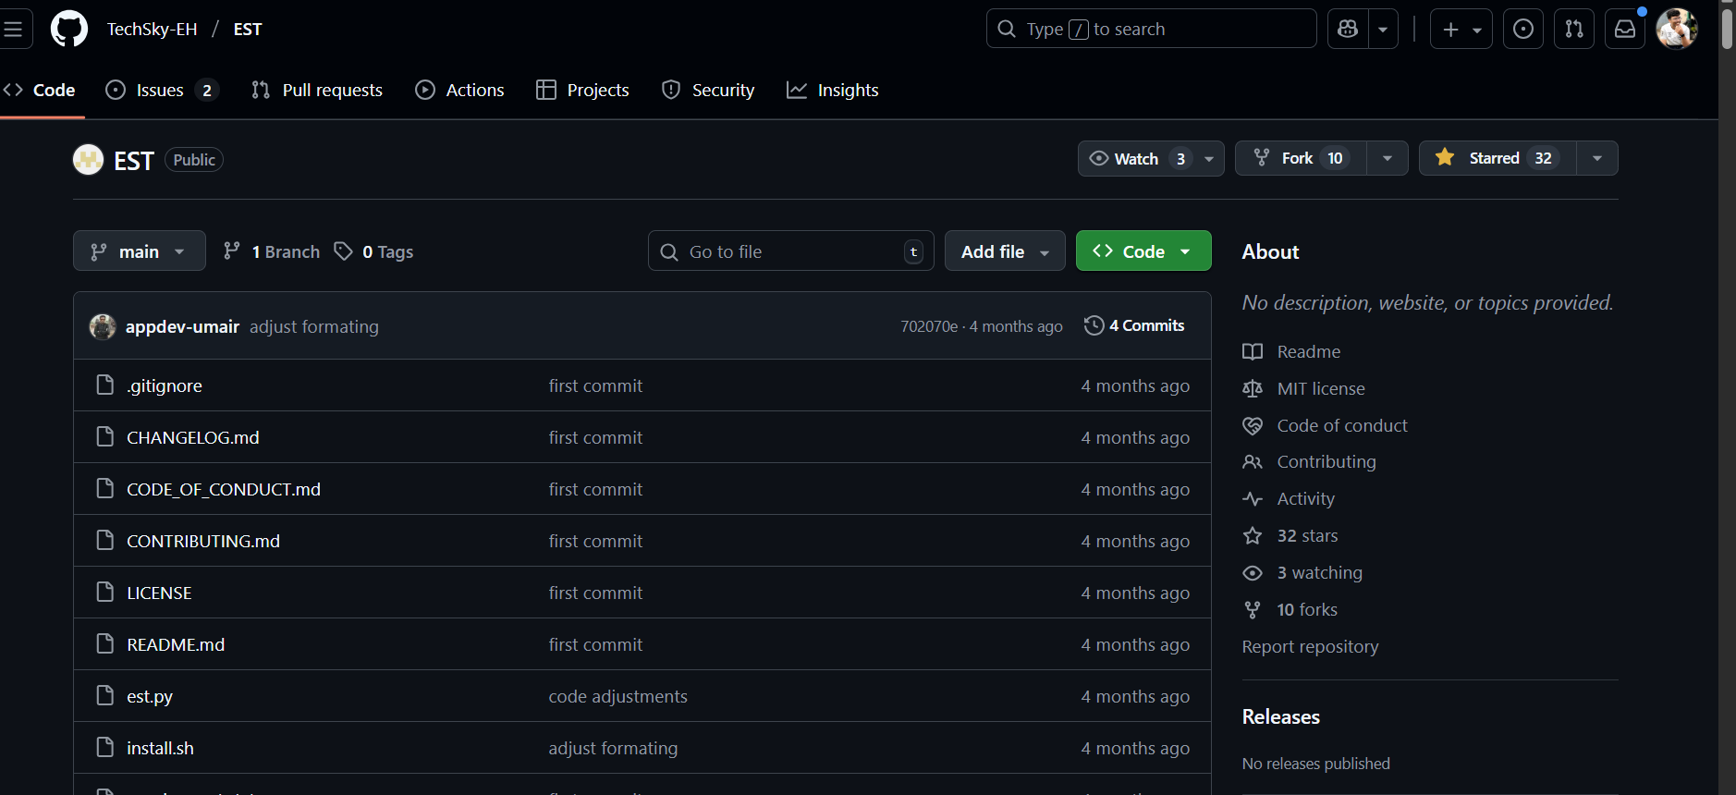

* [EST](https://github.com/TechSky-EH/EST) is intended for authorized security testing and educational purposes only. Users must obtain explicit written permission before testing any systems they do not own or have authorization to test. Unauthorized use of this tool may violate local, state, and federal laws. The developers assume no liability for misuse or damage caused by this program..

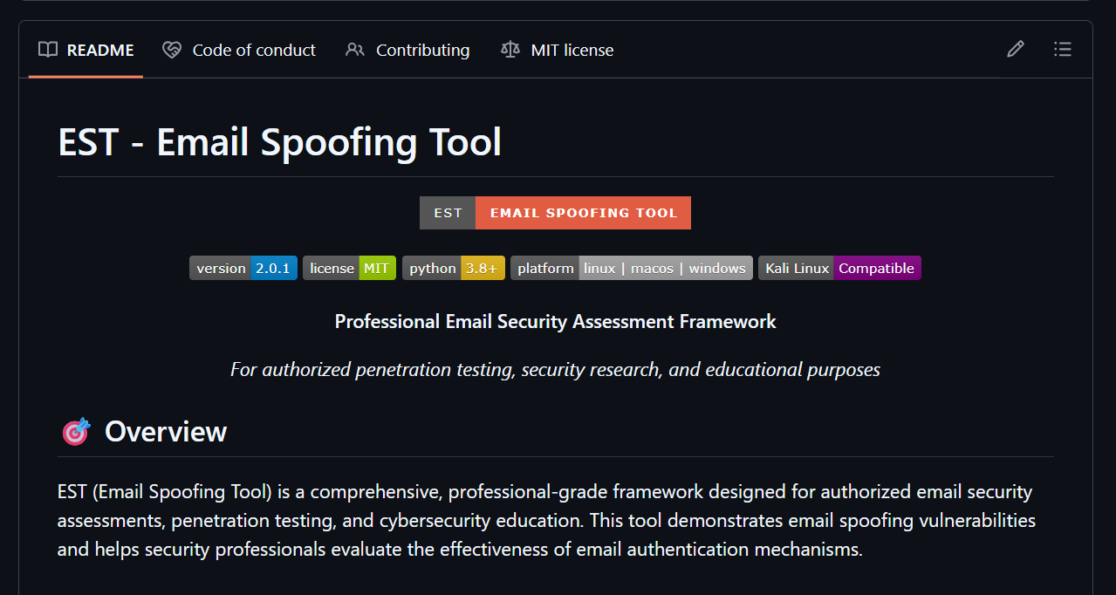

**Tool Installation**

1. Open the browser.

2. Go to the GitHub repository for EST:

https://github.com/techsky-h/EST

3. Copy repo link.

4. Clone the tool in your terminal:

| git clone <https://github.com/techsky-h/EST.git>

5. Enter the directory:

| cd EST

6. List the files: ls (You should see est.py, install.sh, requirements.txt)

7. Make install script executable:

| chmod +x install.sh

8. Run the installer:

| ./install.sh

(Press Y to proceed and enter your password if prompted.)

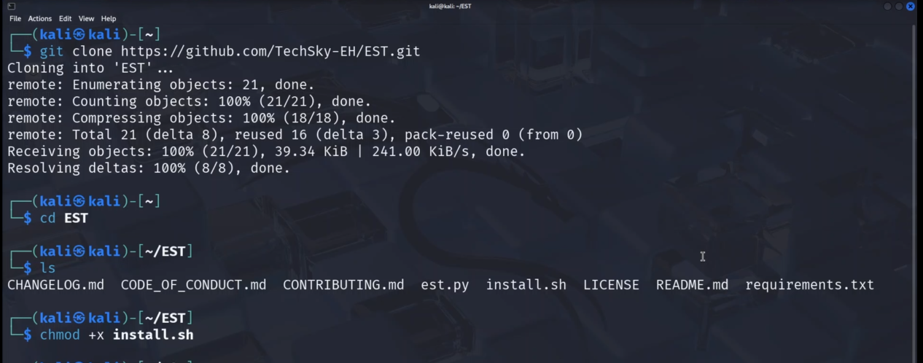

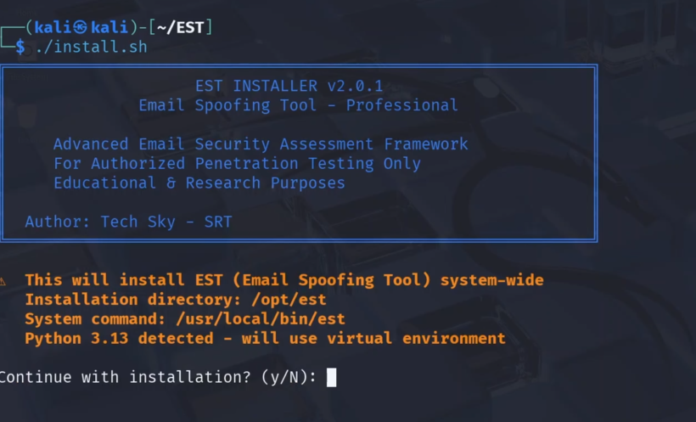

* If any password is asked during the installation, use “kali” as your default password.
* Now you type this command to know the usage.

| est --help

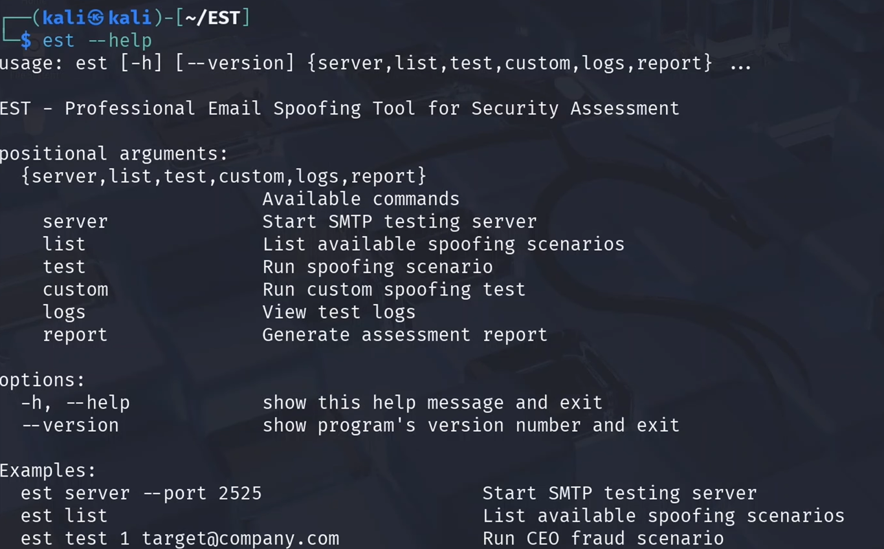

**Step 4: Start Local SMTP Server**

1. In terminal:

| est server --port 2525

(Port 2525 is used for testing, distinct from port 25.)

2. Leave this terminal window running.

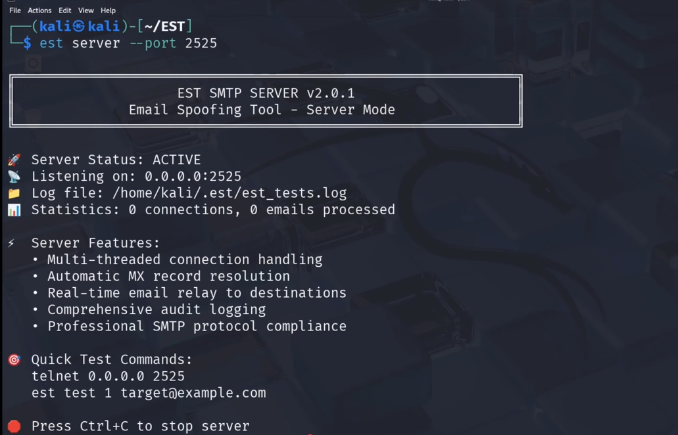

**Step 5: Prepare and Use Spoofing Templates**

1. In a new terminal, list built-in templates:

| est list

(Templates replicate common fraudulent scenarios.)

2. Select a template and test with a recipient email (use a temporary email for safe testing, I used temp mail from temp-mail.org):

| est test 1 recipient@temp-mail.org

(Replace with your chosen template and actual email address.)

3. If its success it will show Email spoofing test completed successfully!

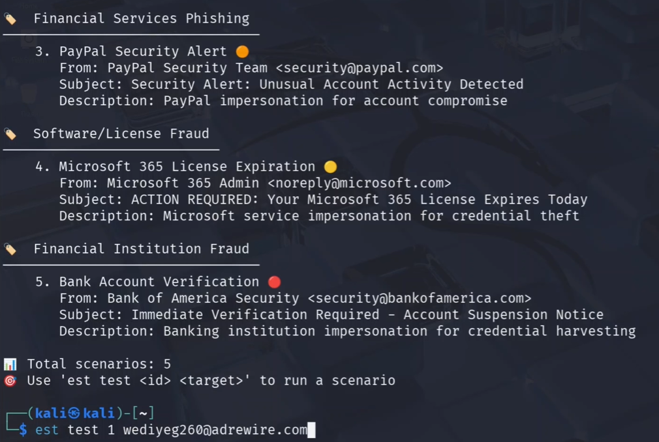

4. Go to your temporary email inbox and refresh; view results.

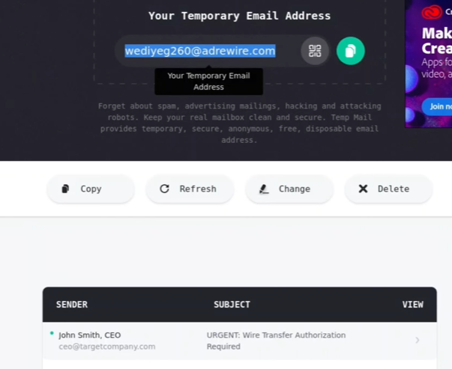

5. The email is successfully received.

**Step 6: Create a Custom Spoofed Email**

1. Craft your own phishing message—example with principal holiday scenario: | est custom \

--from-email principal@xyzcollege.edu \

--from-name "Principal, XYZ College" \

--subject "Today is a Holiday!" \

--body "Dear Students,\nAs per instructions, today a holiday is declared. Please st

--target recipient@temp-mail.org

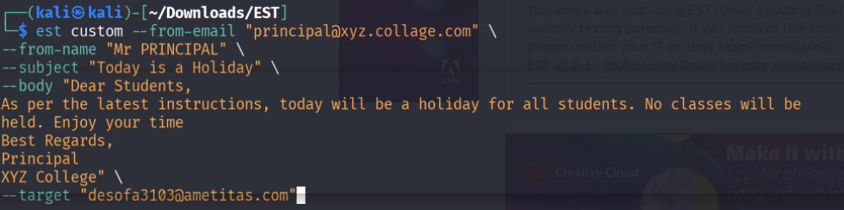

2. Press enter and refresh recipient inbox to verify reception and analyze the spoofed email in your temp mail.

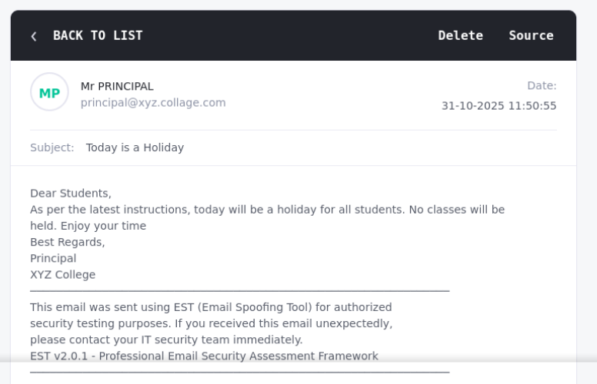

**Step 7: View Activity Logs**

* Return to the original SMTP server terminal; review logs for delivery and attempts.

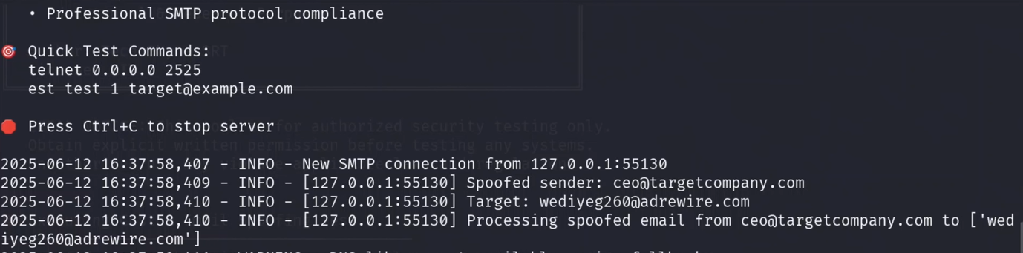

**Step 9: Explanation of Email Security**

* Document the SPF, DKIM, and DMARC checks.
* Note how/why spoofed emails are delivered (lack of proper configuration, etc).

**How Aryan able to do that**

First determine is vulnerable or not, if a domain can be spoofed or is vulnerable to email spoofing, you should:

* Check the domain’s email authentication records online using tools like MXToolBox or EasyDMARC. Specifically, validate that the domain has:
* SPF
* DKIM
* DMARC  
  records are properly configured and enforced.
* **Major email providers like Gmail and Yahoo usually have strict SPF, DKIM, and DMARC** enabled by default. Because of this, you cannot simply spoof their addresses—your spoofed emails will fail security checks and be rejected or marked as spam.
* To spoof an email successfully, you must first find a vulnerability or misconfiguration in the target organization's domain, such as:
  + SPF not set or too permissive
  + DKIM missing or invalid
  + DMARC not enforced (policy not set to “reject”)
* Aryan would start by scanning these weaknesses. Only if authentication is weak or missing can spoofed emails appear to come from that domain and reach inboxes.

Note: *You should never attempt to spoof domains or users without explicit authorization. Always use these tools for testing or educational purposes in a controlled environment.*

**Ethical Disclaimer**

Reiterate that this procedure is for educational/testing purposes within a controlled environment.

Never spoof real users or organizations without explicit permission

## **Conclusion**

The ability to spoof emails largely depends on the target domain’s email security configuration. If SPF, DKIM, and DMARC are properly set up and enforced on a domain—like on Gmail or Yahoo—email spoofing is almost impossible, as unauthorized messages are either blocked or marked as spam. Therefore, successful spoofing or impersonation requires first identifying vulnerabilities or misconfigurations in the organization's domain of email security. This underscores the importance of properly configuring and regularly auditing email authentication records to prevent spoofing attacks.

Keep experimenting—and remember to **snapshot your VM** before making major changes.

Happy virtualization!